Costas Loop

This is another method for extracting the carrier from the received signal in a DSBSC receiver. The block diagram of the Costas loop is given below.

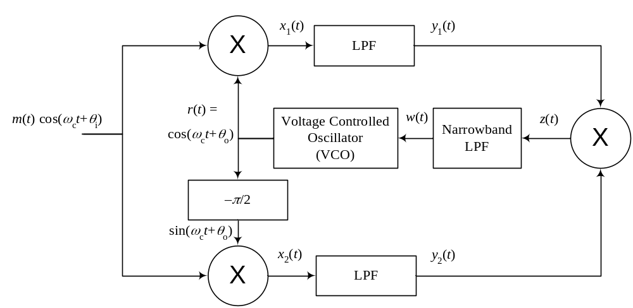
The signals x₁(t) and x₁(t) in the block diagram above are simply obtained by multiplying the received DSBSC modulated signal respectively by cos(ω_{c}t+θ_{o}) and sin(ω_{c}t+θ_{o}), which is obtained by shifting cos(ω_{c}t+θ_{o}) by –π/2. So,

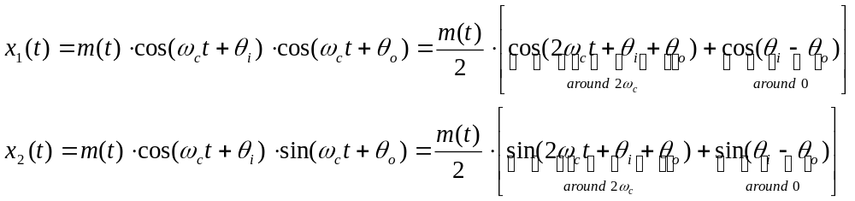.

Since both of these signals has a component around 2ω_{c} and a component around 0 frequency, the high–frequency components of these filters will be rejected by the LPF and only the low–frequency components will pass. So,

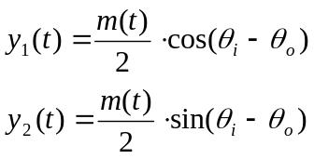.

These two signals are multiplied to produce the signal z(t), which is given by

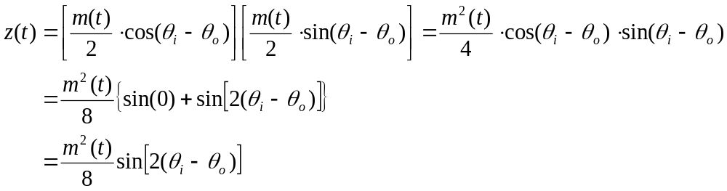.

The signal z(t) is a baseband signal. It is zero only if θ_{i} = θ_{o}. When this is the case, the output signal w(t) of the following Narrowband LPF will be zero, and therefore, the input to the VCO is zero. This zero signal tells the VCO to just stay at its current frequency and phase because they are the correct values. Assuming that we started with θ_{i} = θ_{o} but eventually the carrier of the received signal started to speed up (or slow down) a little so (θ_{i} – θ_{o}) became a small positive (or negative) value, the signal z(t) will become the positive (or negative) square of the message signal. This signal contains a positive (or negative) DC value since it is the square of the message signal. Therefore, using a narrowband LPF that is designed to extract only the DC value of this signal will produce a positive (or negative) number that is proportional to (θ_{i} – θ_{o}). So, the signal w(t) will be

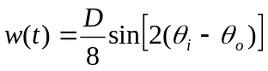,

Where D is the DC value of m²(t). Assuming the difference (θ_{i} – θ_{o}) is small, the value of w(t) will be a small positive number when (θ_{i} > θ_{o}) and a small negative number when (θ_{i} < θ_{o}). This signal will either force the VCO to speed up to catch up with the advancing phase of the received signal or slow down to allow the received signal to catch up with it.

Note that the output of this system according to your book is the signal y₁(t). This is in fact the demodulated output signal. However, if you only needed to extract the carrier signal from the received modulated signal, then the signal you are interested in is r(t).

Carrier Acquisition in SSB

The above techniques do not work for SSB (try using the signal squaring method for a SSB signal). Therefore, the process of obtaining the carrier of the transmitted signal at the receiver when using SSB requires some help from the transmitter by transmitting a carrier with a very small amount of power compared to the message signal. The purpose of this carrier is different from the carrier in Full AM. The amplitude of the carrier in Full AM is to simplify the demodulator by using an envelope detector. This carrier in fact contains most of the power of the transmitted signal. Transmitting the low–power carrier in SSB allows the receiver to know the frequency and phase of the carrier used in the modulation. This is done by using a narrowband BPF at the frequency of the carrier to extract that low–power signal and then amplifying it. The power of that carrier signal is just a small fraction of the power of the transmitted signal (1/20 the power of the transmitted signal for example).

